

SEND Policy

The Governing Body of
Norton Church of England Primary School

This policy is reviewed annually
Date updated: March 2026
Next review date: March 2027

Section 1- compliance and general statement:

Norton Primary School values the contribution that every child can make and welcomes the diversity of culture, religion and intellectual style. The school seeks to raise achievement, remove barriers to learning and increase physical and curricular access to all. All children with special educational needs are valued, respected and are equal members of the school.
Provision for children with SEND is a matter for the school as a whole; all teachers are teachers of children with SEND. The governing body, Head teacher, SENCO and all other members of staff have important responsibilities.

This policy complies with the statutory requirement laid out in the Special Educational Needs and Disabilities Code of Practice 0-25 Years (April 2015) and has been written with reference to the following guidance and documents:

- Equality Act 2010: advice for schools DfE (Feb 2013)
- SEND Code of Practice 0-25 Years (April 2015)
- Schools SEN Information Report Regulations (2014)
- Safeguarding Policy
- Accessibility Plan
- Teachers Standards (December 2021)
- United Nations Convention on Rights of the Child (1991)
- The Children and Families Act (2014)

This policy has been created by the SENCO in liaison with the Headteacher, SEN Governor, SLT and staff with due regard to the input of parents and pupils with SEND.

In compliance with the SEN Code of Practice (2015) and SEN Reforms, there is a graduated approach to the identification, provision and support of all pupils. This includes a period of close monitoring and targeted provision prior to the consideration being given to place a child onto the school SEND register. Should a pupil require provision that is additional to their peers, a conversation will be held with parents about their child moving onto the SEND Register.

Section 2- aim (the longer view)

The overarching aim of this policy is to ensure that the needs of all pupils with SEND and the barriers to their learning, are accurately identified and effectively met, so that all children are able to achieve and develop well, both as individuals and as members of the community, living life with dignity and independence (UNCRC).

Therefore we aim to:

- Assess pupils accurately, track their progress and adjust their provision where needed.
- Ensure that all lessons are accessible and inclusive to children with SEND, differentiated where needed to meet children’s needs.
- Ensure that teaching and learning is multi-sensory and engaging for all.
- Regularly adapt and review interventions and additional support, using a careful blend of in-class support and withdrawal.
- Explore available resources to support learning, taking into account individual learning styles.

Through the application of this policy we wish to:

- Ensure compliance with National SEND Policy, most currently the DfE SEND Reforms, Children and Families Act 2014 and the SEND Code of Practice 2015.
- To encourage all pupils to develop a respect for human rights, respect for parents, their own and other cultures and the environment (UNCR, Article 29).
- Support pupils with SEND to develop their personality, talents and abilities to the full (UNCR, Article 23)
- To operate a ‘whole pupil’ approach to the provision for all children.
- Ensure all staff implement the school’ approach to the management and provision of SEND and understand that ‘every teacher is a teacher of SEN’.
- Ensure there is no discrimination or prejudice
- Recognise, value and celebrate all pupils’ achievements.
- Involve the pupil in the process of identification, assessment and provision and to ensure that the pupil is aware that his / her wishes are taken into account as part of the process and of the shared responsibility in meeting needs.

Section 3- a graduated approach to support SEND pupils at Norton Primary School
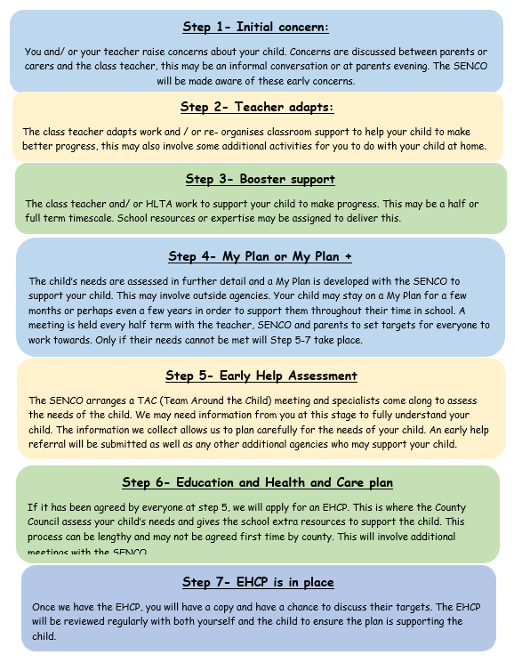

Step 1: Early Identification of need:

At Norton Primary School we believe that children are entitled to have their needs identified, assessed and addressed at the earliest possible stage. If the school is aware that a child has Special Educational Needs and Disability before they enter school, every effort will be made to liaise with the early education setting, other agencies and the parents/carers to enable the school to develop a My Plan and provide additional support if necessary and practicable.

If a child is identified as having a Special Educational Need after Baseline Assessment (at the start of Reception), the school will endeavour to:
- Use information from the child’s previous educational experience to provide starting points for the development of an appropriate curriculum for the child.
- Identify the child’s skills and highlight areas for early action to support the child within the class using a ‘my assessment’.
- Use assessments to identify what the child knows and understands, as well as to identify any learning difficulties.
- Provide regular feedback to parents/carers about the child’s achievements and experiences which will form the basis for the next stages of learning.
- Involve parents/carers in developing and implementing a joint approach at home and in school.

Step 1-3: Identifying needs by looking at progress:

The principle test of the need for SEND support is evidence that current rates of progress are inadequate. Where progress is not adequate it is necessary to take some additional, or different, action to help the pupil learn more effectively.

Adequate progress can be defined in a number of ways: it might for instance, be progress that:
- closes the attainment gap between the child and the peer group
- prevents the attainment gap growing wider
- is similar to that of peers starting from the same base line but less than that of the majority of the peer group
- matches or betters the child’s previous progress
- demonstrates an improvement in self -help, social or personal skills
- demonstrates an improvement in the child’s behaviour

Need may be identified under 4 main categories:
- Communication and Interaction Need
- Cognition and Learning Need
- Social, Emotional and Mental Health Needs
- Physical and / or sensory needs

Step 4: Initial identification of need:

For an example of an My Plan please see Appendix 1.

My assessment: this helps a child or young person share important information in order to support those working with them, to understand their preferences, goals and self-image.

My plan: this is put in place to support a child by addressing areas of need and writing a plan with agreed outcomes in order to meet the identified additional needs. At this point, the views of the child and their families are taken into account by being involved in the planning meeting and helping to set goals for the child.

It focuses on three or four short-term targets and includes information about the teaching strategies to be used, the provision to be put in place, resources and the review date. Plans are reviewed each short term. The review meeting is organised for the parents/ carers, SENCO and generally attended by the class teacher and any TAs involved in supporting the child.
At this stage, help may be requested by the school, with the permission of the parents/carers, from external support agencies. Initial advice is usually sought from the Advisory Teaching Service or the Speech and Language Therapy Service. Advice may also be sought through the Outreach Service.

The child may be taken off SEND support if progress is now adequate, remain SEN support with a new Plan, or be recommended for My Plan+.

My Plan +: after My Plan has been in place and reviewed several times with no progress, it may be deemed necessary to widen the breadth or focus of provisions being made. If so, a decision could be made to move to a My Plan +. This would involve professionals/ outside agencies and would be co-ordinated by the SENCO.

Step 5 -7: Education, Health and Care Plans

Please note that steps 5-7 may take up to 12 months to be agreed by the local authority.

For an example of an EHCP please see Appendix 2.

For children and young people with more complex needs a co-ordinated assessment process using the 0-25 Education, Health and Care plan (EHC plan) will take place.
The purpose of an EHC plan is to make special educational provision to meet the special educational needs of the pupil, to secure the best possible outcomes for them across education, health and social care and, as they get older, prepare them for adulthood.

To achieve this, local authorities use the information from the assessment to:
• establish and record the views, interests and aspirations of the parents/carers and child or young person
• provide a full description of the child or young person’s special educational needs and any health and social care needs
• establish outcomes across education, health and social care based on the child or young person’s needs and aspirations
• specify the provision required and how education, health and care services will work together to meet the child or young person’s needs and support the achievement of the agreed outcomes

EHC plans should be forward-looking documents that help raise aspirations and outline the provision required to meet assessed needs to support the pupil in achieving their ambitions. EHC plans should specify how services will be delivered as part of a whole package and explain how best to achieve the outcomes sought across education, health and social care for the child or young person.

Pupils with a physical disability gain access to the curriculum through my plans or EHCPs These may include adaptations to the environment or adapting teaching plans (such as during PE) so that all children can participate in all areas of the curriculum.

Once a year the EHCP will be reviewed by the SENCO and external agencies, here the provision may be adapted to support the child further.

For further guidance, please refer to section 9 of the Special Educational Needs and Disability Code of Practice 2014.
Section 4- criteria for exiting the SEND record of need

The SENCO has responsibility for the removal of a pupil from the SEND register at Norton Primary School. The decision will be dependent upon appropriate progress being made towards set targets and in conjunction with appropriate teaching staff, outside agencies and parents.

Section 5- supporting pupils at Norton Primary School with medical conditions

The school recognises that pupils at school with medical conditions should be properly supported so that they can have full access to education, including educational visits and physical education. Some children with medical conditions may be disabled and where this is the case, the school will comply with its duties under the Equality Act 2010.
Some pupils also have SEND and may have an EHCP which brings together health and social care needs, as well as special educational provision and the Code of Practice (2015) is followed.
The school has a number of members of staff trained in Paediatric and General First Aid and, where appropriate, staff are trained in managing the medication and other treatments of pupils with medical conditions.
The school follows guidance published by the DfE which can be found at www.sendgateway.org.uk

Section 6- monitoring and evaluating SEND at Norton Primary:

Norton Primary School, including the governing body, is committed to regular and systematic evaluation of the effectiveness of its work. The school employs a series of methods to gather relevant data, including:
- regular observation of teaching by the SENCO, Head and subject leaders
- tracking of children’s work, including children with SEND- either through the National Curriculum or Pre-Key Stage standards.
- monitoring by the SEND governor
- maintenance of records of reading and spelling ages, National Curriculum levels, which illustrate progress over time
- Staff meet each short term to review progress and the impact of interventions

As a result of the above the school reports annually upon its successes and identifies aspects for future development.

Section 7- training and resources

- All professional development needs are identified through the school’s appraisal system and self evaluation, feeding into the School Development Plan.
- The SENCO undertakes an annual audit of Staff Skills and SEND knowledge in order to recognise and address gaps within the school and for individuals
- The Headteacher oversees the professional development of all teaching staff, which occurs during whole school training days, staff meetings and by attending courses.
- The SENCO regularly attends continuing professional development training courses and attends SEND network meetings in order to keep up to date with local and national development in SEND.

Section 8- roles and responsibilities

The SENCO will:
- Oversee the day-to-day operation of the SEND policy
- Co-ordinate provision
- Track the progress of children with SEND, including monitoring interventions.
- Lead SEND team meetings
- Liaising with, and advise, teachers and teaching assistants
- Administrate reviews of both My Plan’s and My Plan+ ’s
- Administrate Annual Reviews for children with EHC Plans
- Liaise with parents/carers of children with SEND
- Liaising with external agencies, including the Local Authority advisory services, Educational Psychology Services and Health and Social Services

Senior Leadership Team will:
- Take the responsibility for the day-to-day management of all aspects of the school’s work, including provision for children with Special Educational Needs and Disabilities.
- The Head Teacher will keep the Governing Body fully informed on SEND issues.
- Will work closely with the SEND team, and share responsibility for liaising with outside agencies.

The SEN Governor will:
- Help to raise awareness of SEND concerns both within school and nationally at governing board meetings.
- Monitor the quality and effectiveness of SEND provision.
- Work alongside the SENCO to strategically develop the SEND provision.

All teaching and non-teaching staff will:
- Participate in reviews of both My Plan’s and My Plan+ ’s
- Be fully aware of the procedures for identifying and assessing (on Insight where appropriate).
- Be fully involved in providing for the needs of the children with SEND in their care, in setting individual plans, and collecting additional information for the SENCO and other agencies.
- Set suitable learning challenges, responding to pupils’ diverse needs, overcoming potential barriers to learning and for monitoring progress.
- The TA should liaise with the class teacher on planning, pupil response and progress.

The Governing Body will:
- Have agreed this policy and the procedures related to pupils with Special Educational Needs and disabilities (SEND).
- Determine the staffing, funding arrangements and generally oversee the school provision and work.

The role of the pupil:
- Pupils are encouraged to take an active role in monitoring targets. If possible, the SENCO seeks the views of each child regarding their progress at each review meeting and a discussion will take place about their thoughts of school and what they find easy or difficult.
- A SEND pupil survey will be carried out twice a year to gather advice on improving the school provision.

The role played by parents/carers of pupils with SEND:

In accordance with the SEND Code of Practice, the school believes that all parents/carers of children with SEND should be treated as equal partners. We value and accept the positive role and contribution parents/carers can make, and strive to work in full co-operation with them. Parents/carers are encouraged to work with the school and other professionals to ensure that their child’s needs are identified properly and met as early as possible. For parents of children on the SEND register, a survey will be carried out twice a year to gather advice on improving the school provision.

At Norton Primary School, we endeavour to support parents/carers so that they are able to:
- recognise and fulfil their responsibilities as parents/carers in playing an active and valued role in their child’s education
- have knowledge of their child’s entitlement within the Special Educational Needs Framework
- understand procedures and documentation
- make their views known about how their child is educated
- have access to information, advice and support during assessment and any related decision-making process about special educational provision.

Families of pupils with SEND are guided towards the County Council Local Authority’s support service e.g Glos Families Website
www.glosfamiliesdirectory.org.uk/kb5/gloucs/glosfamilies/home.page
with regard to the LA Local Offer for SEND in accordance with Regulation 51, Part 4.

The Governing Body of Norton Primary School endeavours to follow the guidelines laid down in the Education Act 1966 and included in the SEND Code of Practice (2014) in order to:
- Do its best to ensure that the necessary provision is made for any pupil who has a Special Educational Needs and Disability
- Ensure that where the ‘responsible person’ – the Head Teacher or the appropriate Governor – has been informed by the LA/ other Advisory Body that a pupil has Special Educational Needs and Disability.
- Ensure that all teachers are aware of the importance of identifying and providing for those pupils.
- Ensure that provision for pupils with Special Educational Needs and Disability is planned for their learning needs and where possible are included within school activities.
- Ensure the participation of the pupils and parents/carers are at the heart of decision-making.
- There is joint planning and commissioning of services to ensure close co-operation between education, health and social care.
- for children and young people with more complex needs a co-ordinated assessment process and the new 0-25 Education, Health and Care plan (EHC plan) is put in place

Section 9- storing and managing information

- The school complies with General Data Protection Regulations (GDPR)- March 2018.
- The school uses the DfE’s Data Protection: a toolkit for schools (2023) as guidance.
- All staff have received GDPR training and are aware of confidentiality requirements.
- Explicit consent is always sought from parents / carers for the following:
- Involvement of outside professionals to observe, assess or work with the child
- Inclusion in the school programme: ELSA
- The SENCO ensures that all sensitive personal information, about individuals and their families is stored securely and is not freely accessible.
- The SENCO ensures that no sensitive, personal data about individual pupils with SEND is visible anywhere in the school including, offices, staffroom and classrooms, unless it is required for safeguarding- in which case, explicit consent is gained.

Section 10 – SEND funding

Funding for SEND is received through the Local Authority budget. There is a separate budget allocated for those pupils with an EHCP. This funding is for administration, teaching support, other agencies and materials. In addition, the SENCO receives a small budget to spend on resources in collaboration with class teachers.

The school will correspond with outside agencies; however, parents must understand that the Educational Psychologist and some Speech and language therapists are beyond national funding and therefore may be financially dependent.

Section 11- Accessibility

Please refer to the Accessibility Plan. This can be accessed at: www.norton.gloucs.sch.uk/information/send

Section 12- dealing with complaints

The school’s standard complaint system applies. More information can be found at: www.norton.gloucs.sch.uk/information/school-policies

Section 13- bullying

Please refer to the school’s Behaviour Policy which is available at: www.norton.gloucs.sch.uk/information/school-policies

Section 14- safeguarding

Children with Special Educational Needs and Disabilities can face additional safeguarding challenges. All staff at Norton Primary School are aware of these challenges.
Further details can be found on the school’s Safeguarding Policy which can be viewed at: www.norton.gloucs.sch.uk/information/school-policies

Section 15- SEND meeting expectations:

All parents / carers are expected to treat all members of staff with utmost respect at all times. If any aggressive, threatening or intimidating behaviour is shown, the parents or carers will be asked to leave school premises.
Norton Primary School will then decide if a member of the senior leadership team will need to attend future meetings and if these can take place on school premises.

Section 16- admission arrangements

The admission arrangements will be the same as for any other pupil as long as the school is not oversubscribed but it must be noted by all concerned that:
-Whilst LA and schools can make any reasonable and objective admission arrangements in the event of over-subscription, those arrangements cannot be used to refuse admission to a child or give the child lower priority than other applicants - simply because the school considers that it cannot cater for his or her SEND.

Appendix 1: example My Plan

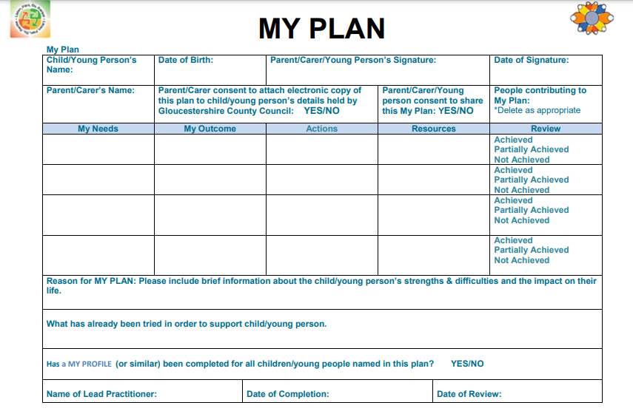

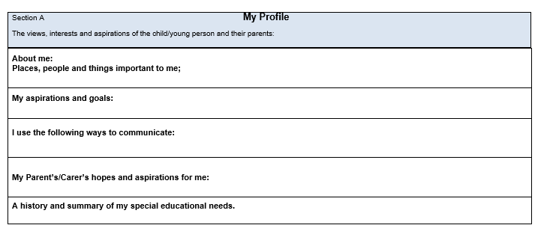
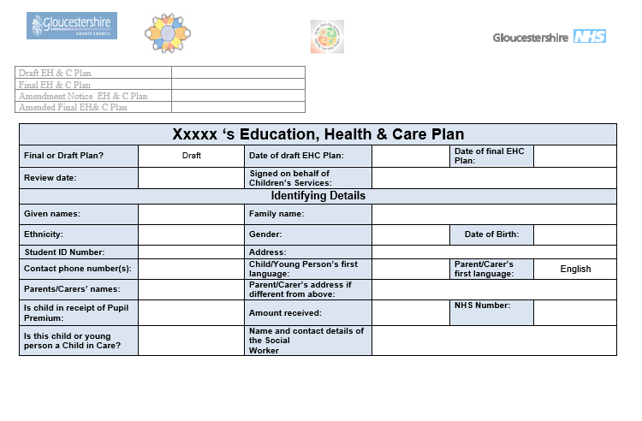
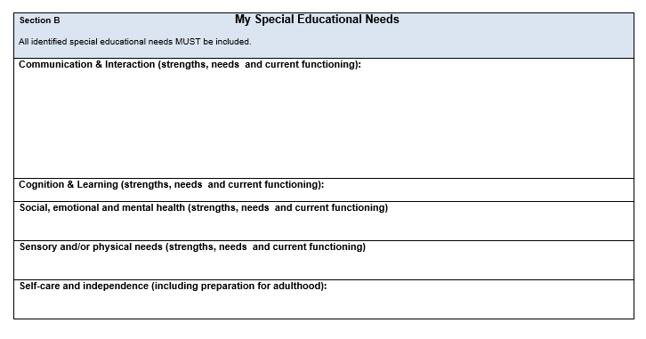
Appendix 2: example EHCP

Appendix 2: example EHCP

